# FORMULARIOS:

**FormCertifRH03**

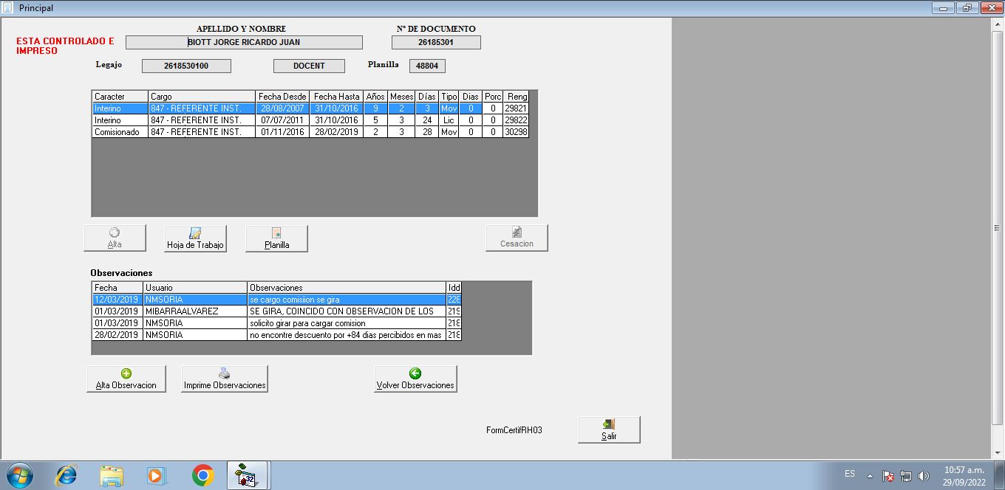

**PROCEDIMIENTO**

Private Sub cmdActadeEntrega_Click()

Dim strSQL As String

Dim FechaRecepcion As String

Dim sSql As String

strSQL = "SELECT DISTINCT pe.Apellido,pe.Domicilio,pe.Localidad ,ma.Empresa" & _

" ,codigopostal = " & _

" CASE " & _

" WHEN localidad ='USHUAIA' THEN '9410' " & _

" WHEN localidad ='RIO GRANDE' THEN '9420' " & _

" WHEN localidad ='TOLHUIN' THEN '9420' " & _

" End " & _

" FROM Personas pe join maestro ma on pe.Documento =ma.Documento Where pe.DOCUMENTO = '" & sdocum & "' "

Set rs = New ADODB.Recordset

rs.Open strSQL, DB, adOpenForwardOnly, adLockReadOnly

If Not rs.EOF Then

apellido_nombre = Trim(sapellido) & " DNI Nº " & sdocum

domicilio = Trim(rs!domicilio) & " - " & Trim(rs!Localidad) & " - C.P " & rs!CODIGOPOSTAL

Empresatc = Trim(rs!Empresa)

If Empresatc = "DOCENT" Then

empdescripcion = "docente"

Else

empdescripcion = "agente"

End If

End If

FechaRecepcion = InputBox("Ingese Fecha de Recepcion del Pedido de Modificacion", "Fecha de Recepción", (Date))

If Not IsDate(FechaRecepcion) Then

MsgBox "Ingrese una Fecha Valida"

Exit Sub

End If

'DB.Execute ("IF OBJECT_ID ('temp_ProntoDespacho') is not null TRUNCATE TABLE temp_ProntoDespacho")

sSql = " TRUNCATE TABLE temp_ActaEntrega INSERT Into temp_ActaEntrega select distinct '" & sdocum & "' as documento ,'" & empdescripcion & "' AS empresa ,'0' AS control,'" & FechaRecepcion & "' AS FechaRecepcion, '" & Date & "' AS FechaPuestaTramite ,'" & Trim(sapellido) & "'AS apellido "

DB.Execute sSql

numero_reporte = 173

Form_Report.Show (1)

End Sub

**PROCEDIMIENTO**

Private Sub cmdaltaObs_Click()

tarea = "A"

txtobsdgh.Text = ""

txtobsdgh.Visible = True

txtobsdgh.Enabled = True

grillaobs.Visible = False

cmdGrabar.Visible = True

End Sub

**PROCEDIMIENTO**

Private Sub cmdCesacion_Click()

Unload Me

FormCertifRH02.Show

End Sub

**PROCEDIMIENTO**

Private Sub cmdGrabar_Click()

Dim strSQL As String

Dim idd As Single

If tarea = "A" Then

strSQL = "INSERT INTO [CERTIFICACIONES OBSERVACIONES] (planilla, fecha, usuario, observaciones,dependencia)" & _

"VALUES (" & Planilla & ",'" & Date & "', '" & UCase(susuario) & "', '" & Trim(txtobsdgh) & "','" & Valor_Dep & "')"

DB.Execute strSQL

Else

DB.Execute ("Update [CERTIFicaciones OBSERVACIONES] set observaciones= '" & Trim(txtobsdgh) & "' WHERE Planilla = " & Planilla & " and idd='" & iddobs & "'")

End If

If tarea = "M" Then

strSQL = "INSERT INTO [certificaciones observaciones] SELECT *,'" & Date & "','" & Time & "','" & Terminal & "','" & UCase(susuario) & "','M' FROM Personas.DBO.[certif observaciones] WHERE Planilla = " & Planilla & " and idd='" & iddobs & "'"

DBAuditor.Execute (strSQL)

Else

strSQL = " SELECT max(idd) as idd From [certificaciones observaciones] where planilla=" & Planilla & ""

Set rs = New ADODB.Recordset

rs.Open strSQL, DB, adOpenForwardOnly, adLockReadOnly

If Not rs.EOF Then

idd = rs!idd

End If

strSQL = "INSERT INTO [certificaciones observaciones] SELECT *,'" & Date & "','" & Time & "','" & Terminal & "','" & susuario & "','A' FROM Personas.DBO.[certificaciones observaciones] WHERE Planilla = " & Planilla & " and idd='" & idd & "'"

DBAuditor.Execute (strSQL)

End If

grillaobs.Visible = True

txtobsdgh.Visible = False

txtobsdgh.Enabled = True

carga_grilla2

End Sub